Figure 3. Gene expression Fold Change after HT treatments.
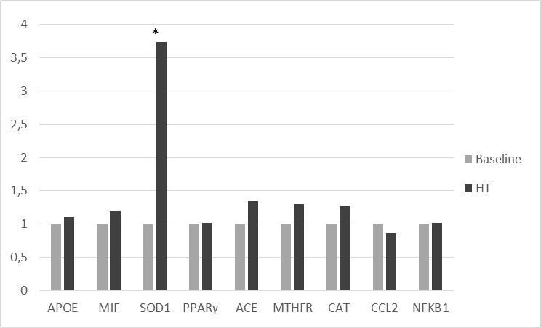
Different levels of fold change of genes analyzed between hydroxytyrosol treatment (HTT) and a Baseline; *p<0.05 between HTT and Baseline.
APOE: Apolipoprotein E; MIF: Macrophage migration Inhibitory factor; SOD1: Superoxide dismutase 1; PPARγ: Peroxisome Proliferator-Activated Receptor Gamma; ACE: Angiotensin I Converting Enzyme; VDR: Vitamin D (1,25- Dihydroxyvitamin D3) Receptor; MTFHR: Methylenetetrahydrofolate Reductase; CAT: Catalase; CCL2: Chemokine (C-C Motif) Ligand 2; IL6R Interleukin 6 – Receptor; NFkB1: Nuclear Factor of Kappa light polypeptide gene enhancer in B-cells; IGF2R: Insulin-like growth factor 2 receptor; USF1: Upstream Transcription Factor 1.

